**Project 3- PWM(Pulse Width Modulation) & And it’s use in Arduino**

|  |  |
| --- | --- |
| * *What is PWM?*   **Pulse Width Modulation**   * *Why need PWM?*   **Digital devices can't produce any other voltage levels as outputs except 0s and 1s (let's say 0V and 5V). By varying the duty cycle of the pulses and their frequency we could easily mimic the intermediate voltage levels.**   * *Where we use PWM?*   **DC Motor speed control, servo motor , LED dimming, alternative of A potentiometer** | **Image result for pwmFig: Pulse Width Modulation (PWM) Signal** |
| **Important Parameters associated with PWM signal**   1. **Duty Cycle** 2. **Period**   The output voltage of the PWM signal will be the percentage of the duty cycle. For example, for a 100% duty cycle, if the operating voltage is 5 V then the output voltage will also be 5 V. If the duty cycle is 50%, then the output voltage will be 2.5 V. | Image result for pwm animated gif |

**Servo motor control with PWM**

* 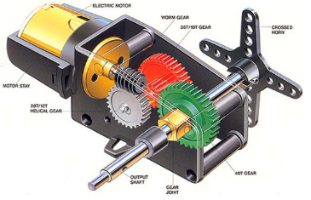What is Servo Motor

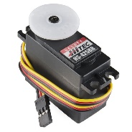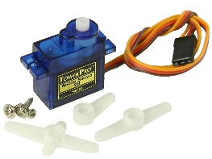

* Why we need PWM in servo?

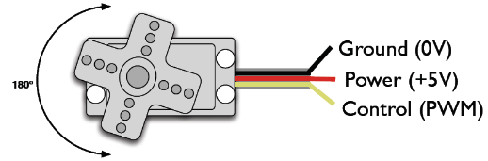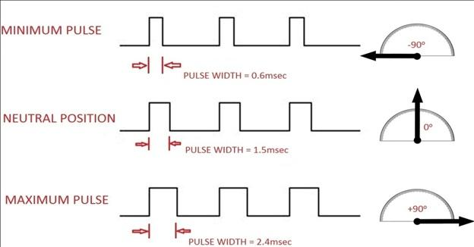

**Circuit Diagram-**

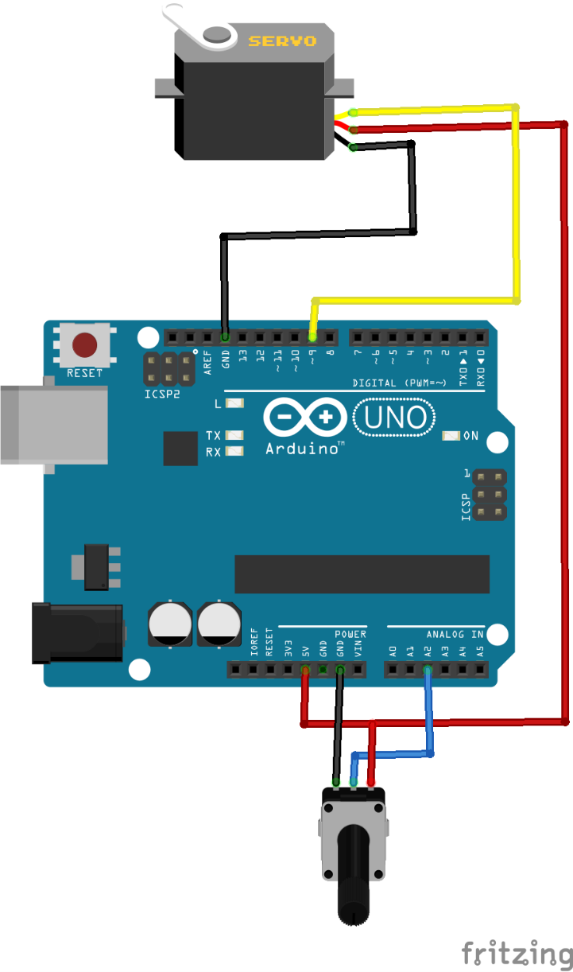

***For This Code Scan The QR Code***